**Task**

Create a React Application named “cricketapp” with the following components:

1. ListofPlayers

* Declare an array with 11 players and store details of their names and scores using the map feature of ES6
* Filter the players with scores below 70 using arrow functions of ES6.

1. IndianPlayers
   1. Declare two arrays T20players and RanjiTrophy players and merge the two arrays and display them using the Merge feature of ES6
   2. Display these two components in the same home page using a simple if else in the flag variable.

**App.js**

import ListofPlayers from './Ex-9/ListofPlayers';

import ListofIndianPlayers from './Ex-9/ListofIndianPlayers';

import {OddPlayers, EvenPlayers} from './Ex-9/EvenOddPlayers';

import {players, IndianPlayers, IndianTeam} from './Ex-9/data'

import ScoreBelow70 from './Ex-9/ScoreBelow70';

function App() {

    var flag = false;

    if(flag == true){

        return (

            <div>

                <h1>List of Players</h1>

                <ListofPlayers players = {players}/>

                <hr/>

                <h1>List of Players having Scores Less than 70</h1>

                <ScoreBelow70 players = {players}/>

            </div>

        );

    }

    else{

        return(

            <div>

                <h1>Indian Team</h1>

                <h1>Odd Players</h1>

                {OddPlayers(IndianTeam)}

                <hr/>

                <h1>Even Players</h1>

                {EvenPlayers(IndianTeam)}

                <hr/>

                <h1>List of Indian Players Merged:</h1>

                <ListofIndianPlayers players={IndianPlayers}/>

            </div>

        )

    }

}

export default App;

**Data.js**

export const players = [

    { name: "Mr. Jack", score: 50 },

    { name: "Mr. Michael", score: 70 },

    { name: "Mr. John", score: 40 },

    { name: "Mr. Ann", score: 61 },

    { name: "Mr. Elisabeth", score: 61 },

    { name: "Mr. Sachin", score: 95 },

    { name: "Mr. Dhoni", score: 100 },

    { name: "Mr. Virat", score: 84 },

    { name: "Mr. Jadeja", score: 64 },

    { name: "Mr. Raina", score: 75 },

    { name: "Mr. Rohit", score: 80 },

  ];

export const IndianTeam = ["Sachin1", "Dhoni2", "Virat3", "Rohit4", "Yuvaraj5", "Raina6"];

const T20Players = ['First Player', 'Second Player', 'Third Player'];

const RanjiTrophyPlayers = ['Ofurth Player', 'Fifth Player', 'Sixth Player'];

export const IndianPlayers = [...T20Players, ...RanjiTrophyPlayers]

**ListofPlayers.js**

export default function ListofPlayers({ players }) {

    return (

        <ul>

            {players.map((player) => (

                <li key = {player.name}>Mr. {player.name}<span>{player.score}</span></li>

            ))}

        </ul>

    );

}

**ScoreBelow70.js**

export default function ScoreBelow70({players}){

    const filtered_players = players.filter(player => player.score <70)

    return(

        <ul>

            {players.map(player => (

                <li key = {player.name}>Mr. {player.name}<span>{player.score}</span></li>

            ))}

        </ul>

    );

}

**ListofIndianPlayers.js**

export default function ListofIndianPlayers({players}){

    return(

        <ul>

            {players.map(player  =>

                <li>Mr. {player}</li>

            )}

        </ul>

    );

}

**EvenOddPlayers.js**

export function OddPlayers([first,,third,,fifth]){

    return(

        <div>

            <li>First: {first}</li>

            <li>Third: {third}</li>

            <li>Fifth: {fifth}</li>

        </div>

    );

}

export function EvenPlayers([,second, ,fourth, ,sixth]){

    return(

        <div>

            <li>Second: {second}</li>

            <li>Fourth: {fourth}</li>

            <li>Sixth: {sixth}</li>

        </div>

    );

}

**Output (flag = true)**

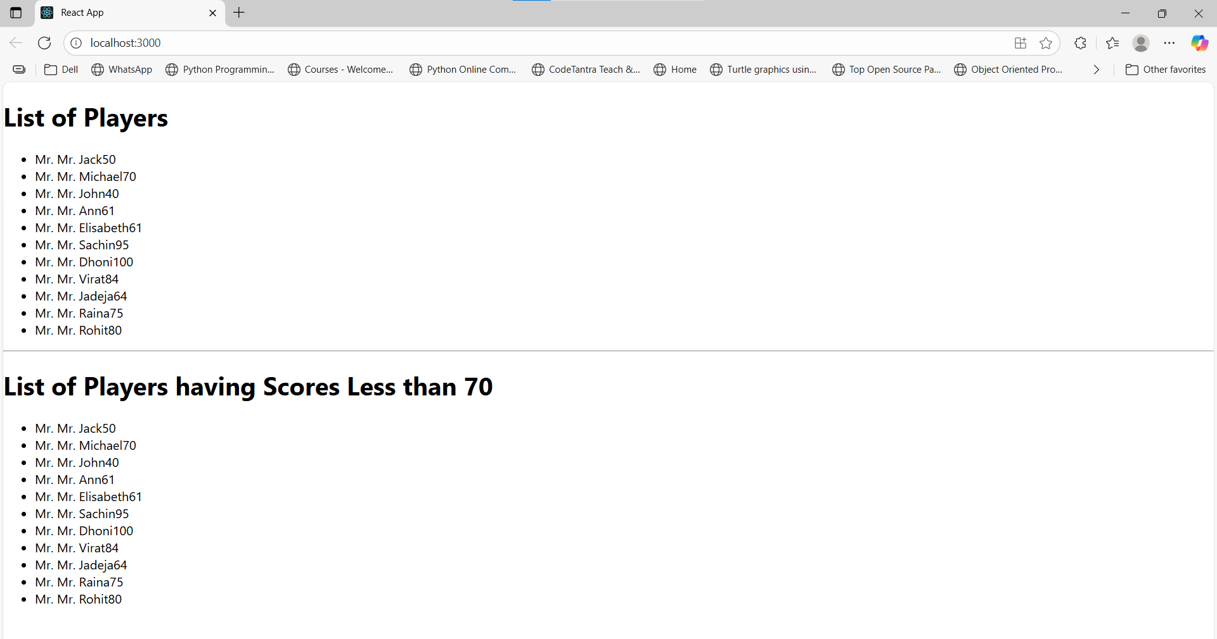

**Output (flag = false)**

